**WEEK -1 : HANDS-ON EXERCISE**

**Data Structures and Algorithms**

**Exercise 2: E-commerce Platform Search Function**

**Big O Notation:**

* Describes how the runtime of an algorithm grows as input size increases.
* Helps to analyze algorithm efficiency without depending on hardware or exact timings.

**Best, Average, Worst-Case:**

|  |  |  |  |
| --- | --- | --- | --- |
| **Type** | **Best Case** | **Average Case** | **Worst Case** |
| Linear Search | O(1) | O(n) | O(n) |
| Binary Search | O(1) | O(log n) | O(log n) |

**INPUT:**

**Product.java:**

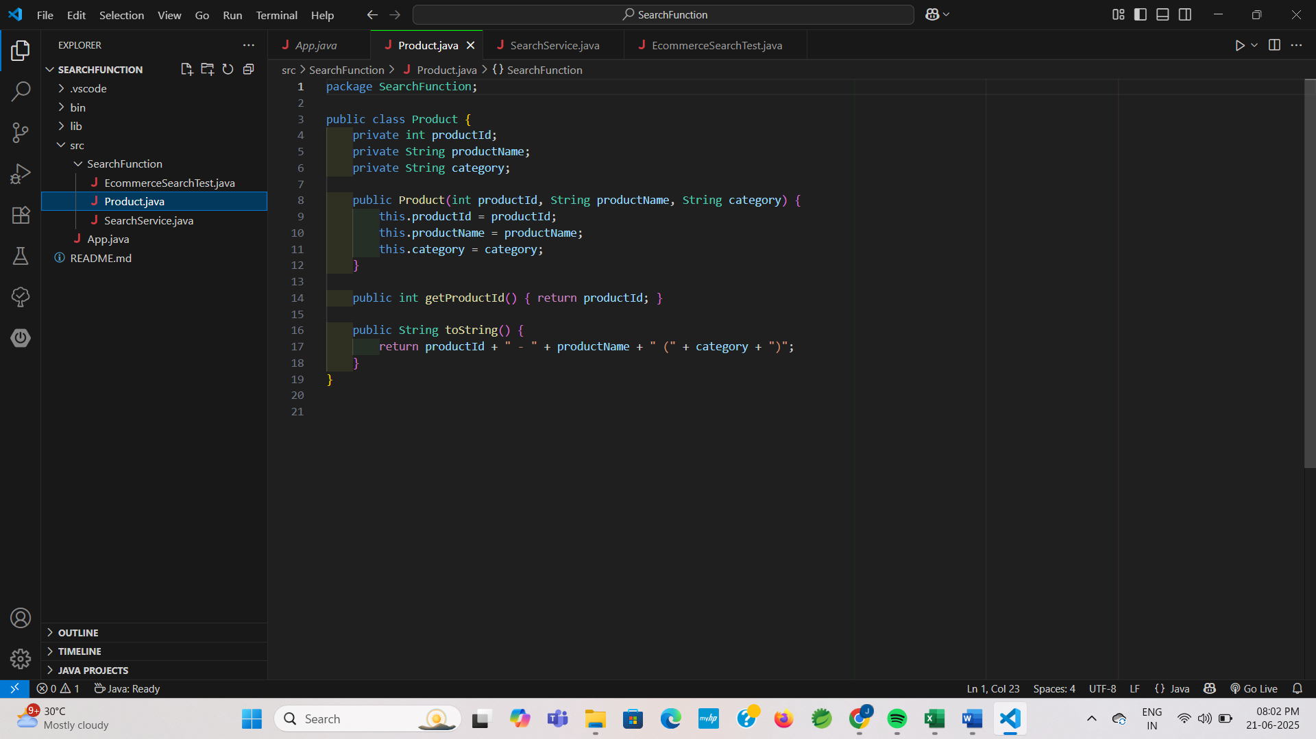

**SearchService.java:**

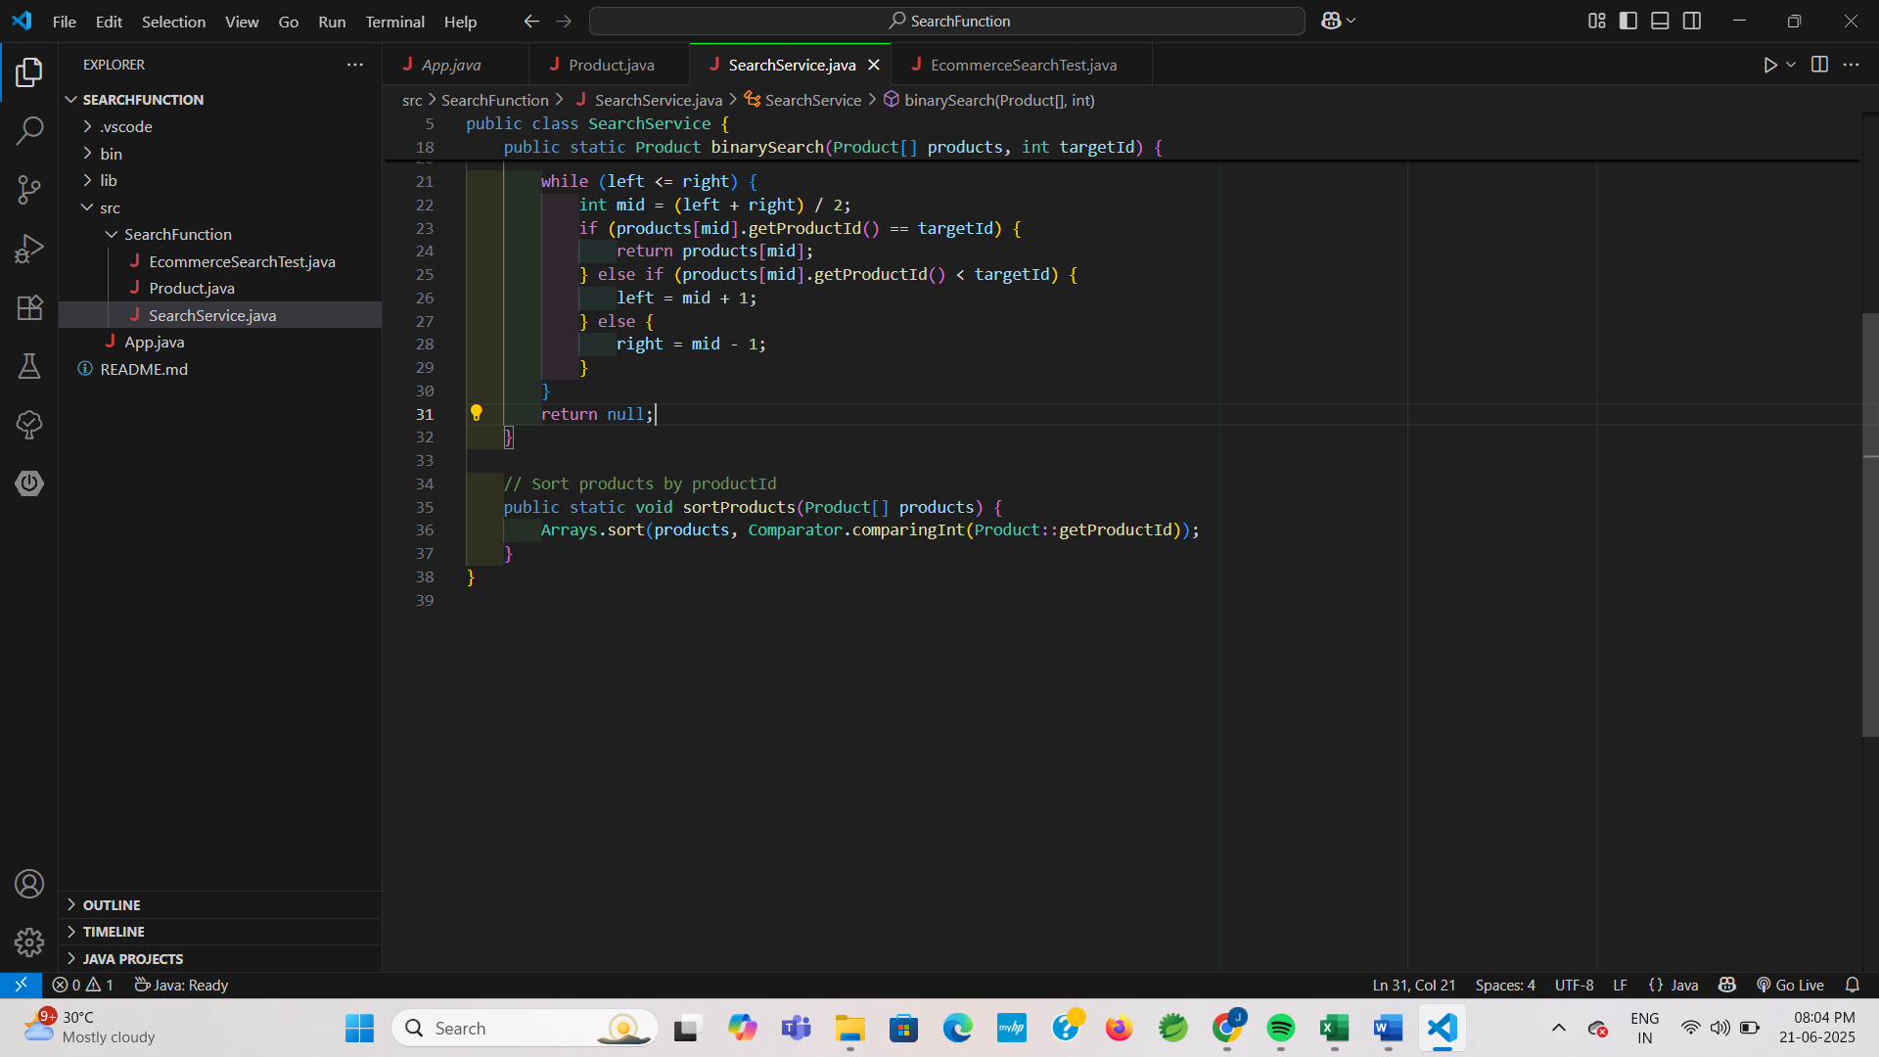

**EcommerceSearchTest.java:**

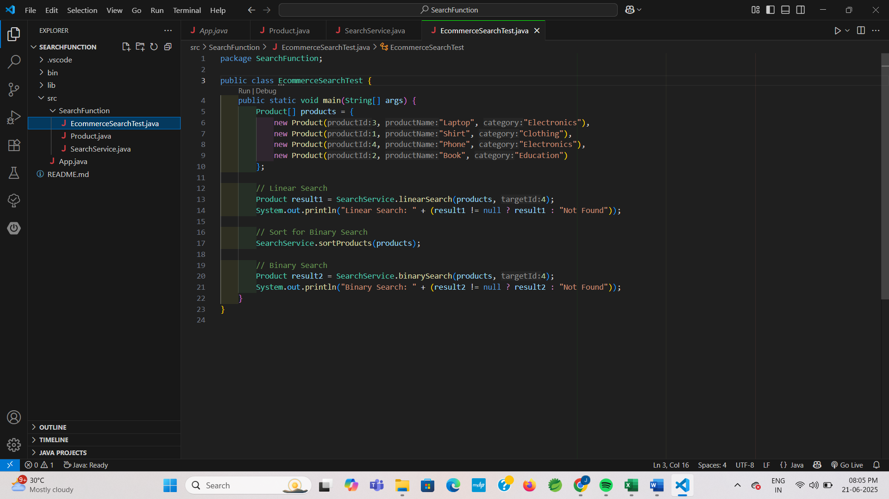

**ANALYSIS:**

|  |  |  |
| --- | --- | --- |
| **Algorithm** | **Time Complexity** | **When to use** |
| Linear Search | O(n) | Small unsorted data |
| Binary Search | O(log n) | Large sorted data |

**OUTPUT:**

